DataStax DevCenter Installation Guide.

DataStax DevCenter is a free visual schema and query IDE for developers, administrators, and others who want to create and run Cassandra Query Language (CQL) statements against Apache Cassandra and DataStax Enterprise. Users can quickly add and create new connections, import previously saved queries, and navigate database instances. Tabbed editors allow administrators to work on multiple database sessions at a time and compare results.

*DataStax DevCenter is a Java application and requires at least JRE 6. The latest JRE is recommended.

Here are the steps of running DevCenter installation;

**Step 1)** First of all, you may take executable file from this location. \\ivl-srv1\VZ Soft\DataStax_DevCenter.

**Step 2)** Copy the zip file on your local machine in “D: drive” and Extract the Zip file.

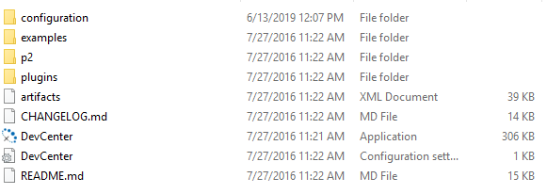

**Step 3)** Double click on the DevCenter executable icon as below image.



You will be presented with the DevCenter user interface. This is where you will create and execute your queries.

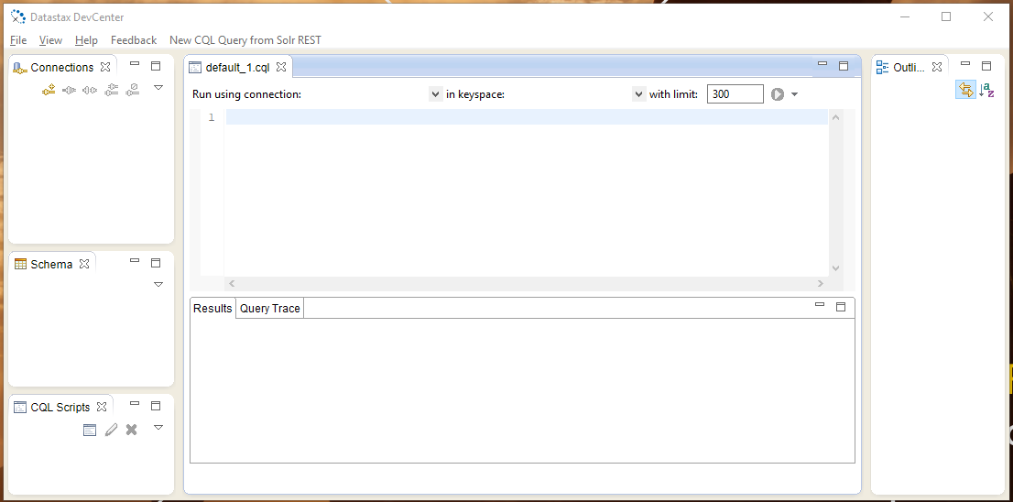

**Step 4)** Create and Name Connection- In this step, you must create a connection with Cassandra enterprise server. Go to connection window and click on the icon as shown here

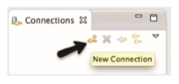

Important Note: - Make sure that Cassandra enterprise server is running.

**Step 5)** After clicking on it, you will be displayed on the following page.

1. Give connection name, you can give any connection name. This is not a specific thing.
2. Provide IP address of the node as Contact hosts, by default it is localhost.
3. Click on “Add button” to add the contact hosts.
4. Provide port number, by default port, is 9042.
5. Next select compression type
6. After providing this information, press “Finish button”.

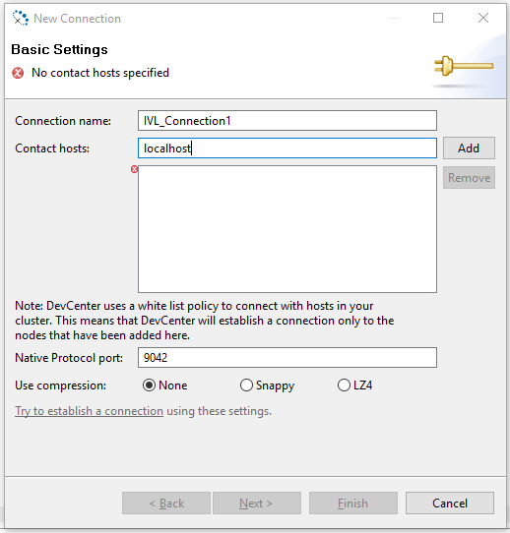

**Step 6)** After clicking Finish button, DevCenter should run successfully.

1. Select "connection" from the drop down. Here I have only one connection that I have been created.
2. Select keyspace from the drop down from which you want to query data.
3. Select a number of records that you want to retrieve and display on the DevCenter User interface.
4. Write the query on query prompt and select the query and press [Datastax DevCenter & OpsCenter Installation Complete Guide](https://www.guru99.com/images/cassandra/021216_0520_DevCenterOp6.png)execute button.
5. After query selection and execute the button, you will be displayed the query result as shown below.

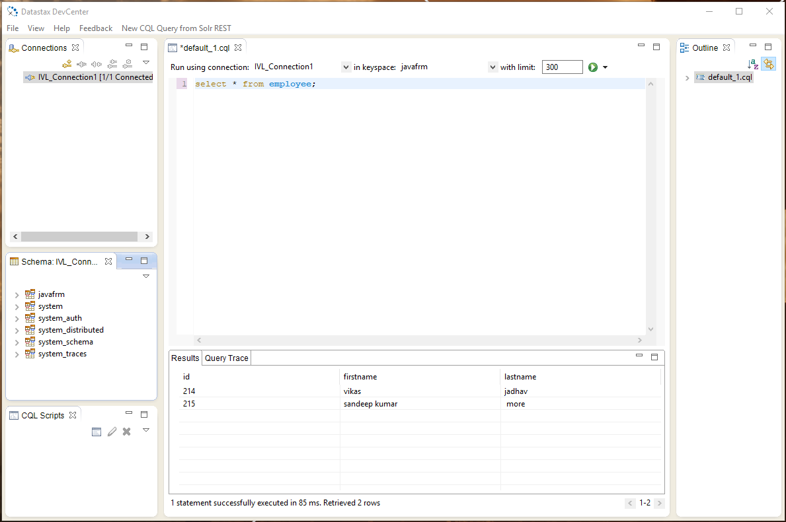

Enjoy and paly with Cassandra Data base. Thanks…😊